Measuring Tubulin Compartment Sizes Experimentally

1. You will upload your image stack to imageJ.
2. Next, identify a region of interest. A compartment.
3. What the movie through and note at which frame the tubulin compartment depolymerizes.
4. In a spreadsheet create a column where you note the frame in which you are analyzing the specific compartment. You can relay this to a separate column and record the time starting at 0 to x (your last frame * the time between frames)
Your excel sheet may look like this: 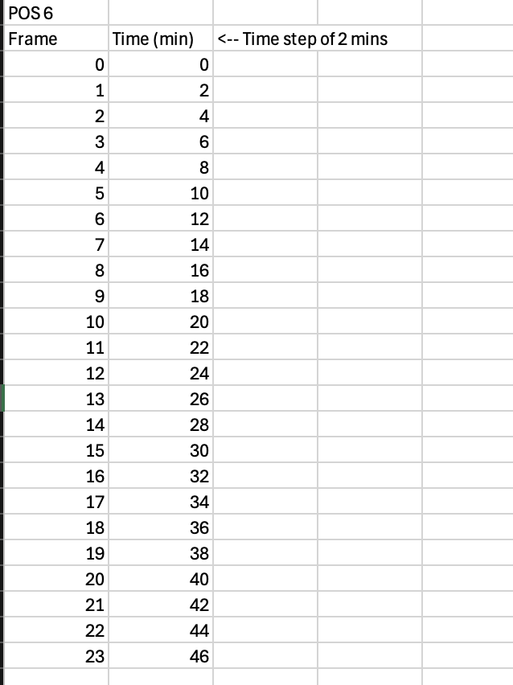
5. Next you will start your measurements from when you can see the cluster start to form. Your measurement may be 0 for the first few frames and that is okay. To measure you will use the line tool I have circled in the image below.
Next, in your image, you will draw a line from two fixed points. 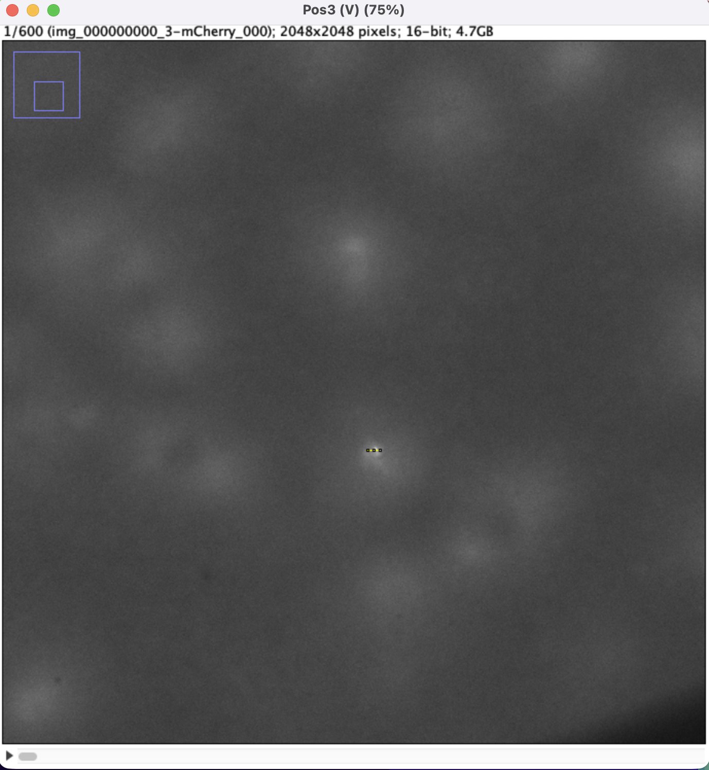
Even at this small of a scale try to not change how you are drawing the line. Since I started horizontal, every measurement from here should also remain horizontal.
6. Now, press Command + m to show your measurement of your line. It should look something like this: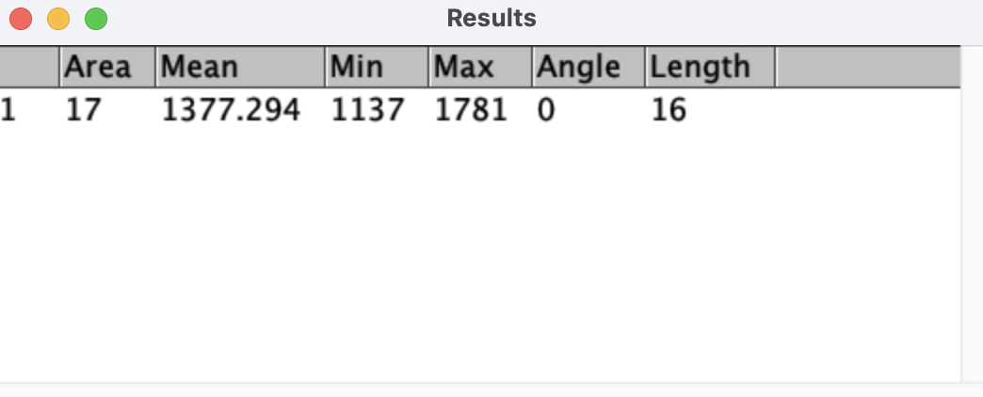
In your excel sheet record this value. I chose to round each of my length values to the nearest 5. So, I would round this to 15. The excel sheet could now look like this: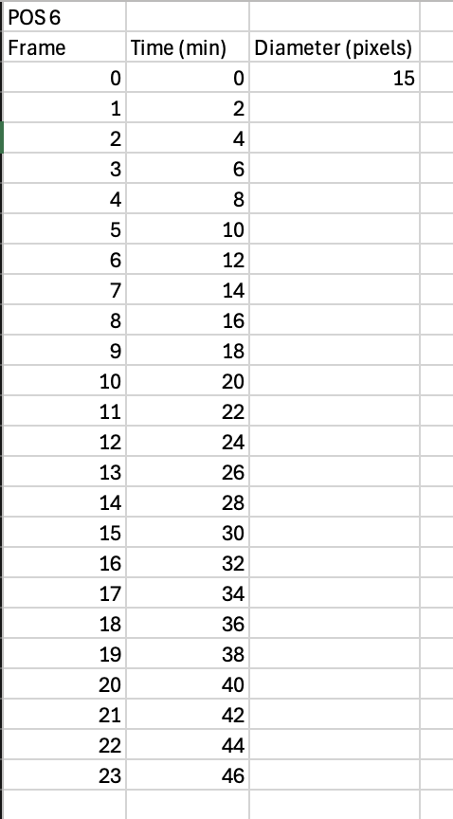
7. You will want to convert your diameter in pixels to microns. A rough approximation is 2.6 microns/pixel. A more accurate conversion will depend upon the microscope you are using and the magnification. Create a new column in your excel to convert your data to microns. 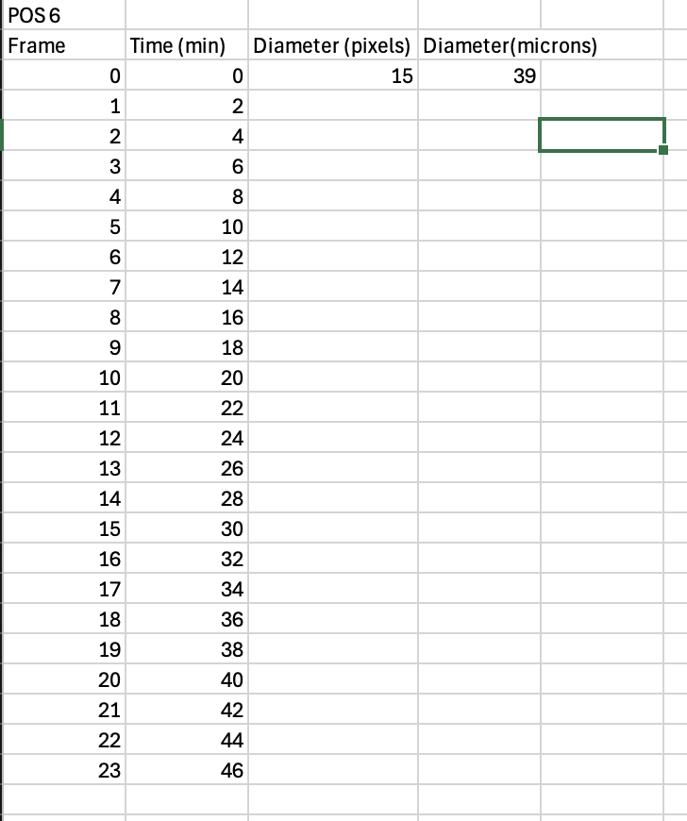
8. Continue this process until your compartments depolymerize. There might be a few frames at the end where you see the compartments intensity decrease. I choose to not record these measurements because I was not sure what that was. Use your discretion here.
9. Repeat this for each cycle until you have multiple sets of data.
10. Now from here, you can interpret the data however you would like. I chose to break each cycle into a growth and stabilization phase. To do this I plotted my time vs. the diameter. It looks something like this:
You can fit this line however you would like. I chose to break apart my growth and stabilization phase with a sigmodal line. You will do this in python, not excel.

You should feed your data into a script like this (this is in the documentation section of the GitHub):
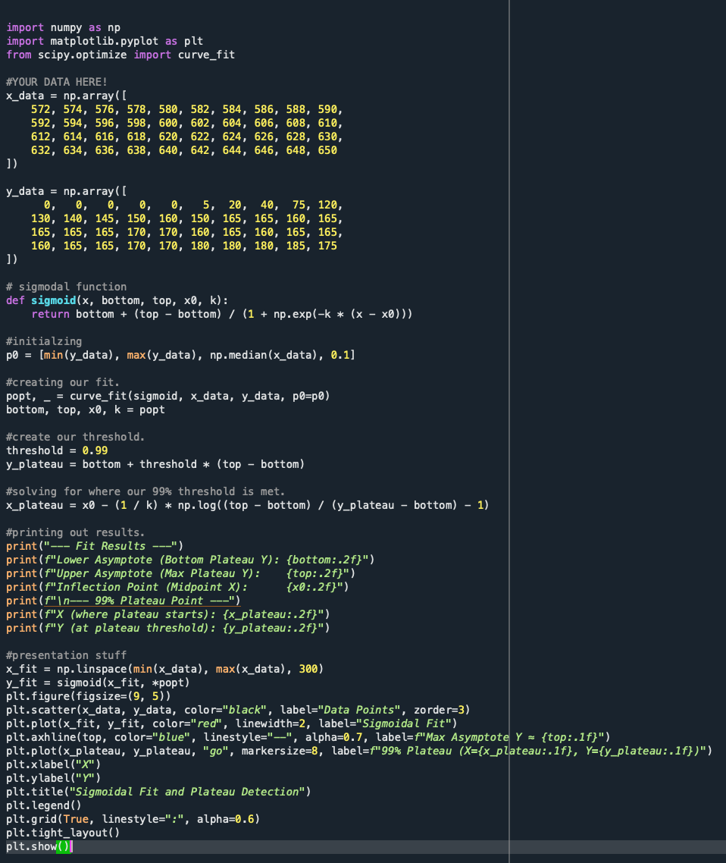
11. From here you can record your approximate max diameter. Also from the data you collected you can measure the period length by finding the total minutes between each cycle.
12. You can go back into you excel and break up the entire compartment lifetime into growth and stabilization based on the max diameter and apply lines of best fit to see the slopes. 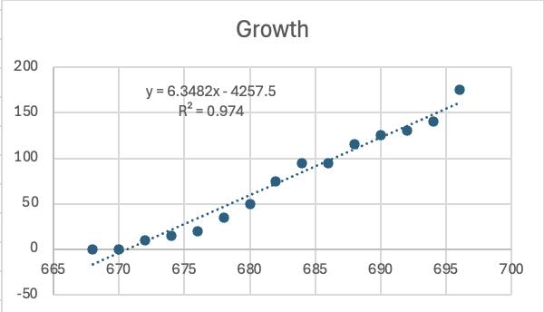
13. You can quantify any relationship here. Some ideas for plots would be:
- growth rate vs. period length
- period length vs. max diameter
- period length vs. cycle #
- growth vs. stabilization
And many more!
14. If you want to quantify the relationship, I recommend applying a log vs. log plot.

REACH OUT IF YOU HAVE ANY QUESTIONS!

